- Create user and client applications

- Create Realm under Root (login to admin first)

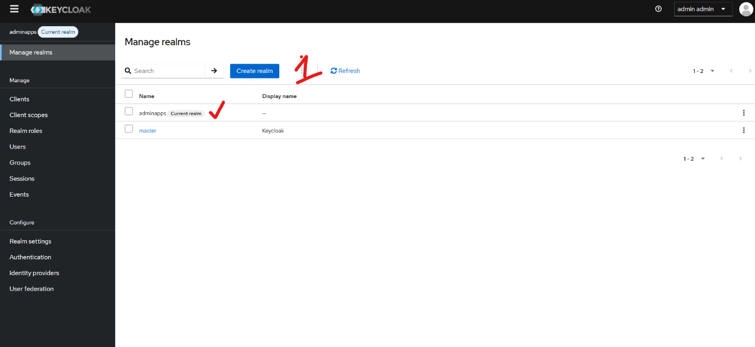

- Selected as new Ream then create the client application

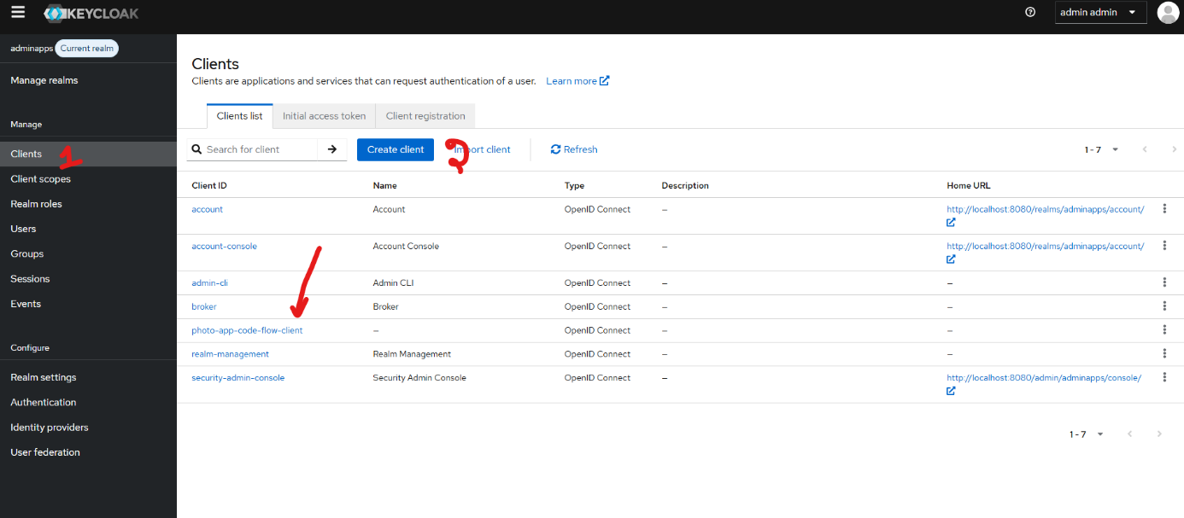

- Create the client ID
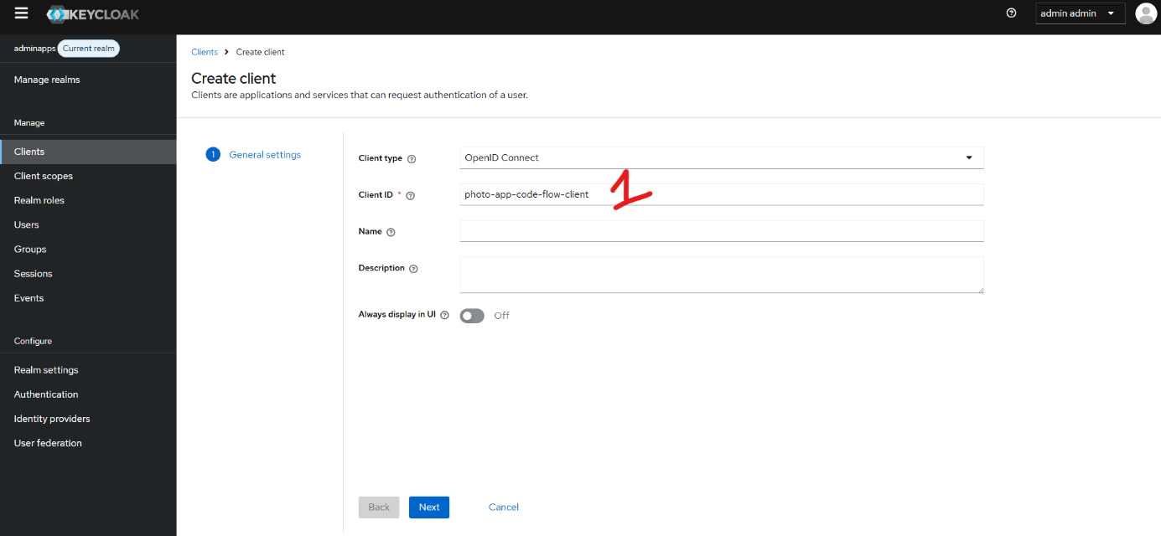

- Capability config (to use the client app)
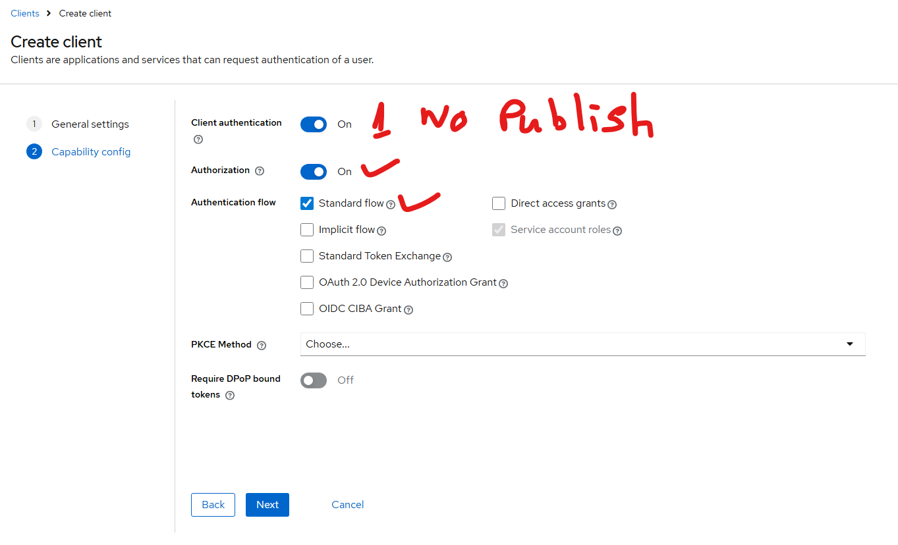

2- URL to get the code verification
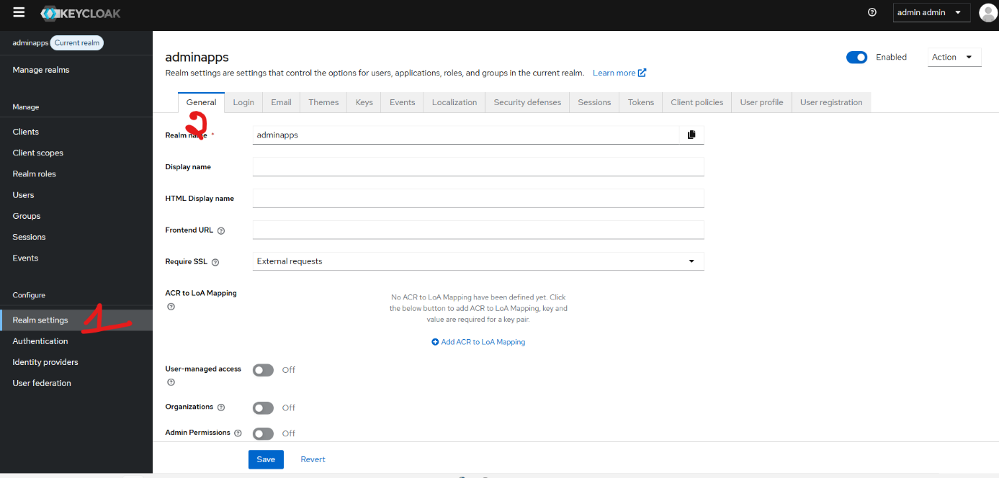

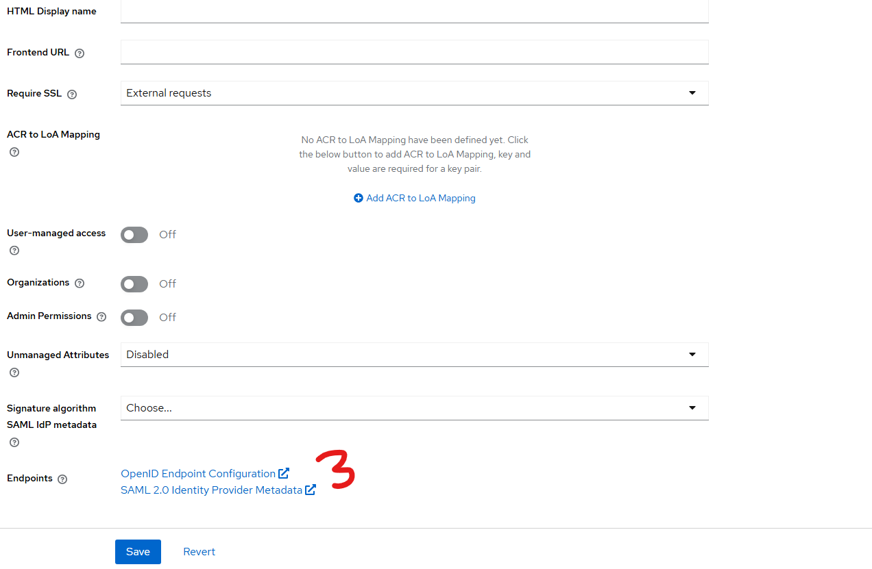

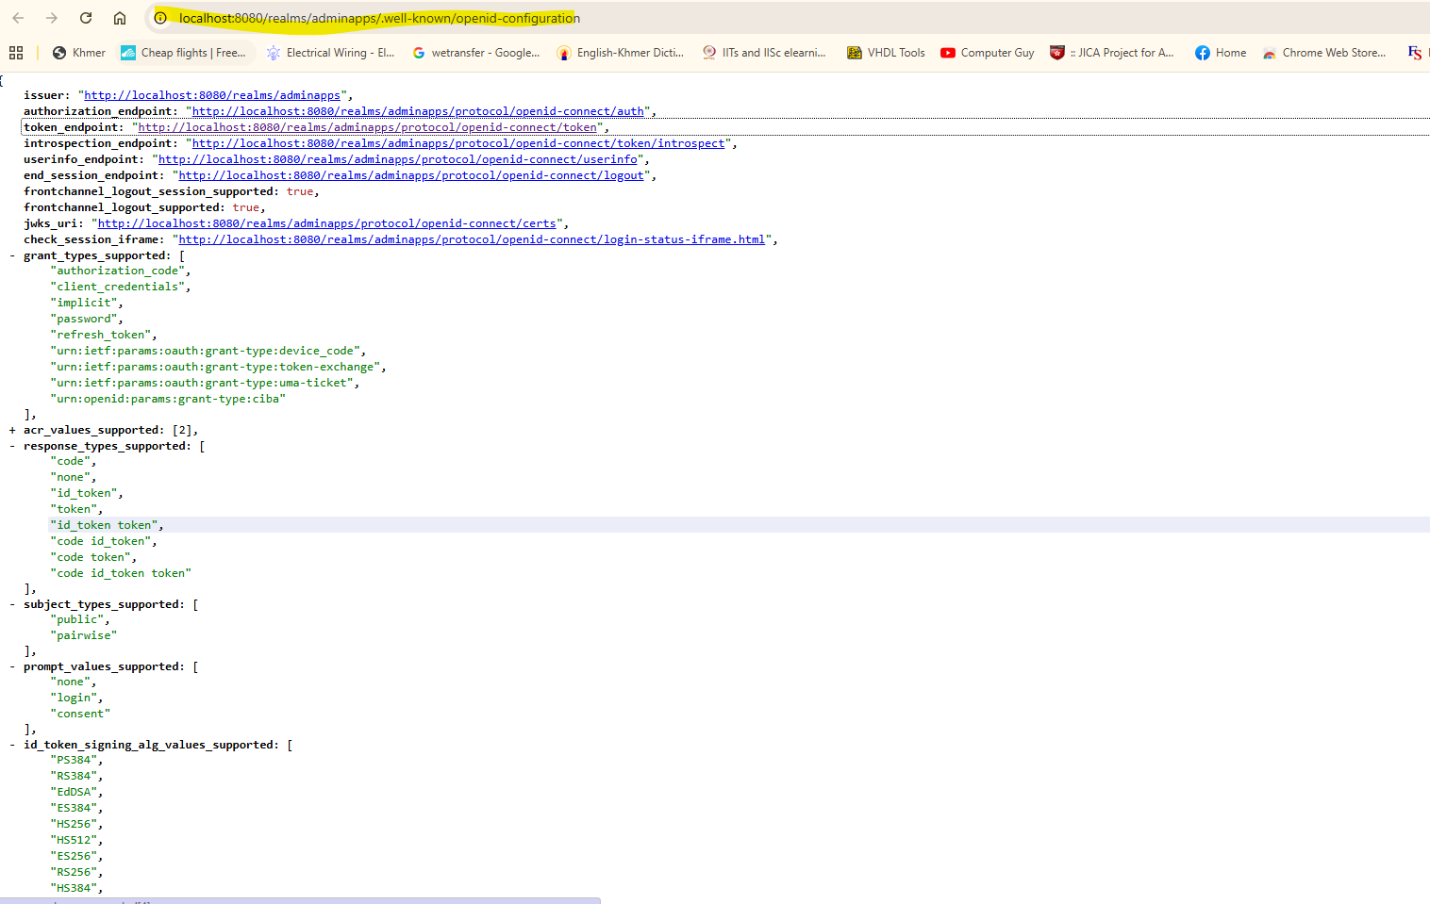

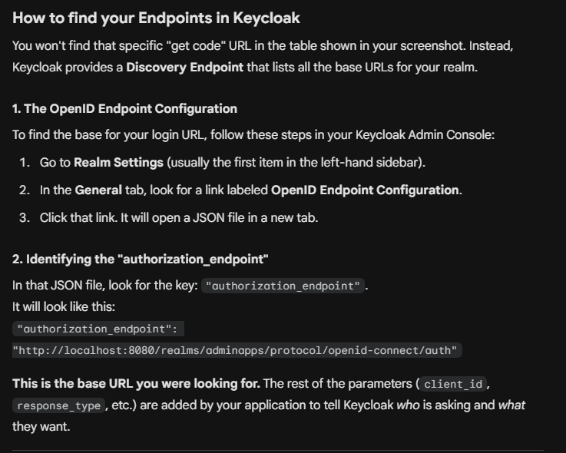

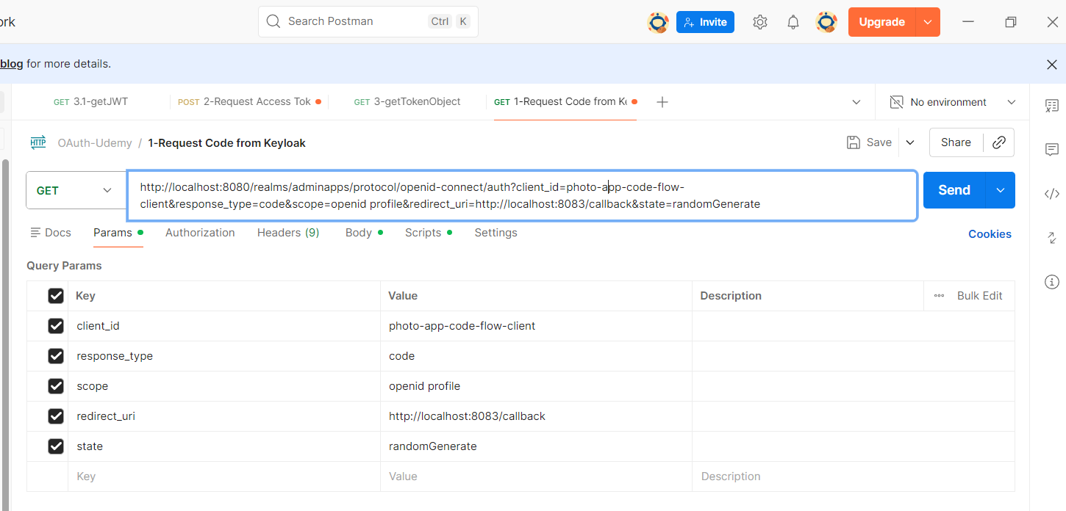

What we request from POSTMain:

http://localhost:8080/realms/adminapps/protocol/openid-connect/auth?client_id=photo-app-code-flow-client&response_type=code&scope=openid profile&redirect_uri=http://localhost:8083/callback&state=randomGenerate

